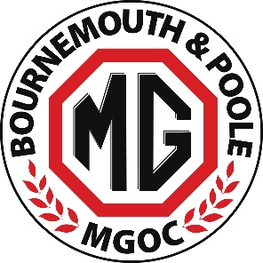
Athelhampton House Garden Party & Picnic - Sunday 18 August 2024
ENTRY FORM

NAME - DRIVER:_________________________________________________________________________

NAME - PASSENGER/S:____________________________________________________________________

Any affiliation to a local MG club or other car club:_____________________________________________

VEHICLE MODEL:_________________________________ REGISTRATION:_________________________

MOBILE PHONE: _________________________________________________________________________

EMAIL: _________________________________________________________________________________
Advance Booking - £10 per person
(includes entry to event and gardens – discounted additional admission fee of £5 for entry to the House )
PAYMENT
Advance entry fees can be paid by cash or by cheque (made payable to ‘Bournemouth & Poole MG Owners Club’) or via credit card at a 1020 club night or via BACS (bank details below)
Account Name - Bournemouth & Poole MG Owners Club
Account Number - 88130398 / Sort Code - 51-81-41
If paying by BACS CLEARLY MARK YOUR PAYMENT WITH YOUR NAME AND THE WORD ‘ATHELHAMPTON’

Total Paid £________________Method Paid (Cash / Cheque / Credit Card or BACS) _______________
- Those booking advance tickets will receive a vehicle pass via email prior to the day
PLEASE RETURN THIS FORM TO CHRIS ADAMSON
Email chris@1020mg.org.uk / Post: Chris Adamson 40 Baring Road, Bournemouth BH6 4DT
Note: Entry also on the day - but the fee will then be £12 per person – cash only please

