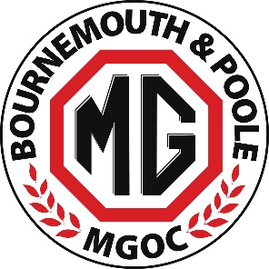
Athelhampton House Garden Party & Picnic - Sunday 13 August 2023
ENTRY FORM

NAME DRIVER:__________________________________________________________________________

NAME PASSENGER/S:_____________________________________________________________________

MG MODEL:___________________________ REGISTRATION:_____________________________

If you are a member of a Regional MG club - which one:_________________________________________

MOBILE PHONE:_________________________________________________________________________

EMAIL:_________________________________________________________________________________
Advance Booking - £10 per person - (includes admission to event and gardens)
New for 2023 – Car Boot Autojumble
Sell items from the boot of your MG in a dedicated Autojumble area
£10 per car (this is in addition to the individual admission fee)
PAYMENT Entry fees for _______ number of people = £_________
Entry fee for Autojumble £______________ Total Paid £___________________
Method Paid (Cash / Cheque or BACS) __________________
Advance entry fee can be paid by cash or by cheque (made payable to ‘Bournemouth & Poole MG Owners Club’)
or BACS (bank details below)
Account Name - Bournemouth & Poole MG Owners Club
Account Number - 88130398 / Sort Code - 51-81-41
PLEASE CLEARLY MARK YOUR PAYMENT WITH YOUR NAME AND THE WORD ‘ATHELHAMPTON’
RETURN THIS FORM TO CHRIS ADAMSON
Email: chris@whizzco.co.uk / Post: Chris Adamson 40 Baring Road, Bournemouth BH6 4DT
Note: Entry also open on the day but the fee will be £12 per person – cash only please

